Problem : No app for desserts

Solution : Exclusive app for desserts

Great Indian Dessert (GID) - Exclusive app for your dessert cravings

Abstract:

Making sweets and desserts available from sweet shops , bakeries and restaurants

1. Restricting the user by geography

2. Can order desserts from other cities (which are famous for it) based on the lifespan of the dessert.

3. Can make bulk orders.

Types of users:

1. Sweet stores, bakeries and restaurants

2. Customers

3. POC

4. Delivery persons

5. Admin

Modules:

1. Seller Module:

# Sellers have to register themselves to get an insight about GID.

# The seller has to select the types of memberships available with us.

# The vendor can tie up with or without delivery professionals,

# After selecting suitable membership they will be redirected towards the payment page.

# The Seller makes the payment to become a member of MulFood.

# A Profile will be created for the Seller.

# There will be an option provided to stop the services with GID .

# The Seller can propose their name,set a profile pic,add banners and add description about them.

# The Seller will be enabled to add their Menus.

# The Seller can add the type,categories,taste,combos and cost of the food and special servings in menu page.

# The Seller will disclose the timings and availability of the food.

# The Seller will have a choice to post offers and discounts.

# Once everything is done the Seller is ready to serve to the customers of GID.

# Seller will be enabled to interact with GID .

# Seller will be enabled with a chat to interact with customers.

# Sellers providing offer have to be stated on their page.

2. Delivery and POC module :

# The delivery persons have to register to join as delivery partner for GID.

# Delivery persons must undergo background check.

# Qualified persons will be provided app to install.

# Delivery persons will be assigned to a delivery based on their current location.

# POC will be notified for bulk and other city deliveries.

3. Admin module :

# Admin handles all the communications involved in the transactions.

# Admin handles all the customer and delivery person complaints.

# Admin handles courier and Transport for Bulk orders.

4. Customer module :

# Customer must download app and register to access GID services.

# Customer can opt for premium or standard memberships where premium memberships provide free delivery*.

# Customer can select desserts from various sellers and their respective menus available

# Customer can filter the required product through search and filters available.

# Customer order will be place after confirming payment mode and clicking place order button.

# Customer can track the package until it is delivered.

# Customer can contact through chat or call.

# Customer can cancel order before order is collected by delivery partner.

# Customer can give rating and feedback to seller and delivery person.

Work Flow :

Seller/ Delivery Partner/ Admin / User:

1. Sign up page : # E-mail id

# Phone number

# Name

# Password

# Confirm Password

# Already Have account then Sign-in (Link)

# Sign up with google account ( Only for User)

# Referral ( Only for User )

2. Sign in page :

# Email id or phone number

# password

# Forgot password

# Register (Link)

Form Page : (Restaurant/Store)

# Restaurant/Store details (Text Boxes)

# Restaurant/Store address(Text Boxes)

#Submit Button

Form Page : (Admin/ Delivery Executive/POC)

# Personal details (Text Boxes)

# Submit Button

Form Page : (Customer)

# Personal details (Text Boxes)

# Home/Office addresses(Text Boxes)

#Submit Button

Home Page : (Restaurant)

# Items Available

# Search Box

# Add/ Remove Items

# Sign Out

Home Page : (Customer)

# Sign in

#Sign up

# Cart

# Help

# Search Box

#Filters

#Location (Current)

# Timeline ( Contains ads and Offers )

#Restaurants / Stores Available (Thumbnails)

#Orders

#Logout

Home Page (Admin)

# Existing Tickets

# Resolved Tickets

# Unresolved Tickets

# Logout

Home Page ( Delivery Agent) :

# Current Order

# Delivery Location

# Previous Orders

Home Page ( POC) :

# Current Orders

# Previous Orders

# Delivery Person Available

Menu Page (Customer) :

# Item list

# Place Order

# Check Boxes

Order Page (Restaurant/Store) :

# Confirmed Orders

# Dispatched Orders

#Canceled Orders

Order Page (Customer) :

# Current Orders

# Previous Orders

#Cancel & Refund Option

# Refund Status

# Reorder

#Rating and Review

Order Placement Page(Customer) :

# Address Selection

# Confirm Order

# Payment

Payment Page (Customer) :

# Payment mode Selection

#Promo Code Field

# Place Order

Wire Frames :

1. User Sign Up :

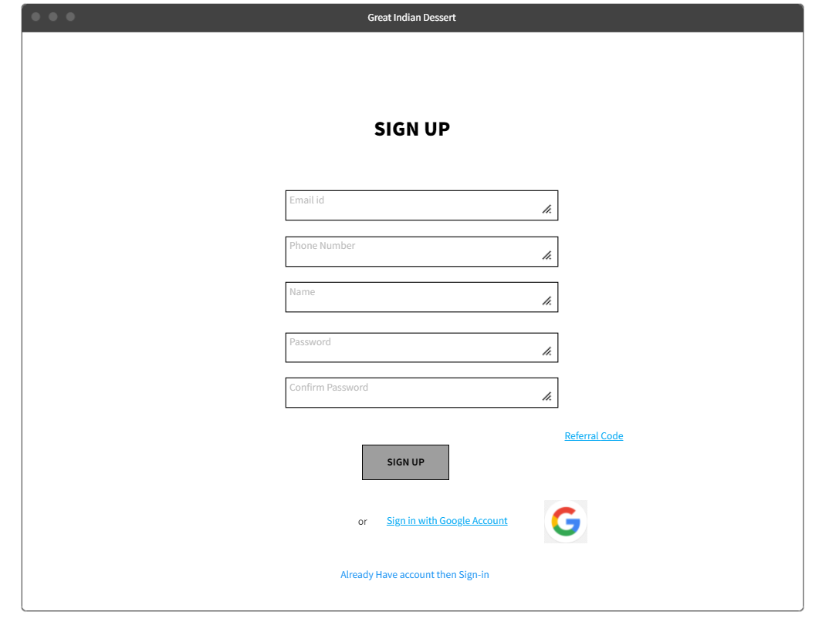

Delivery Agent/Store/POC sign up :

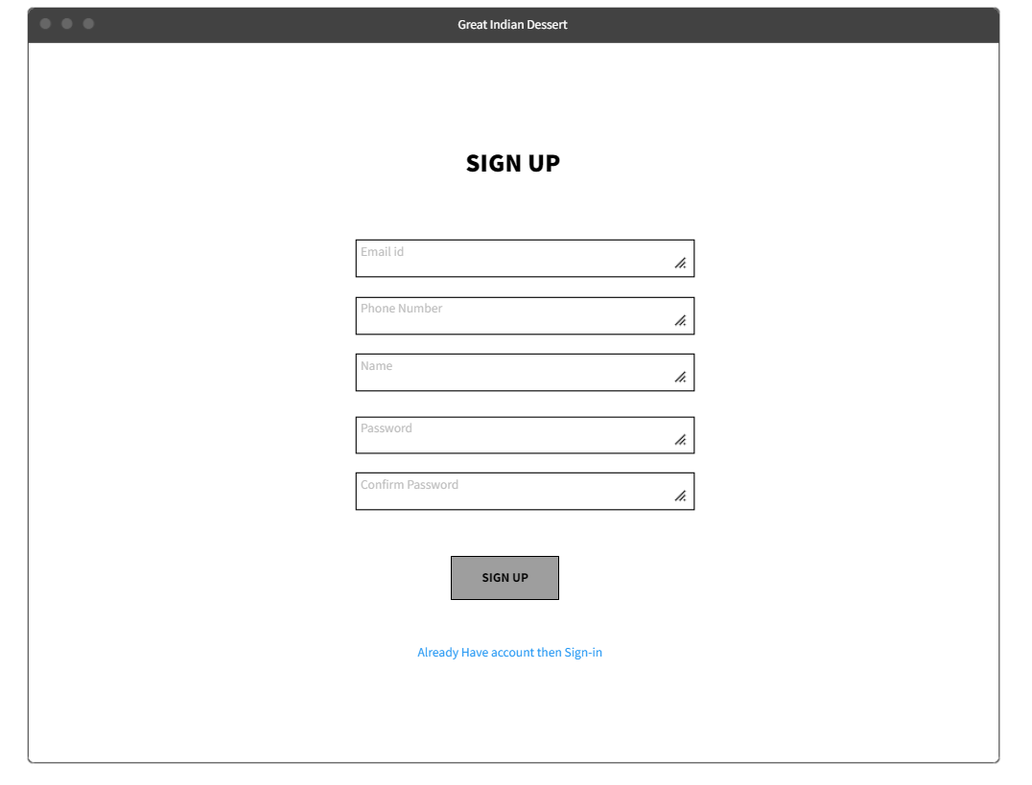

Sign in Page for Customer/ Admin/ Delivery agent/Store :

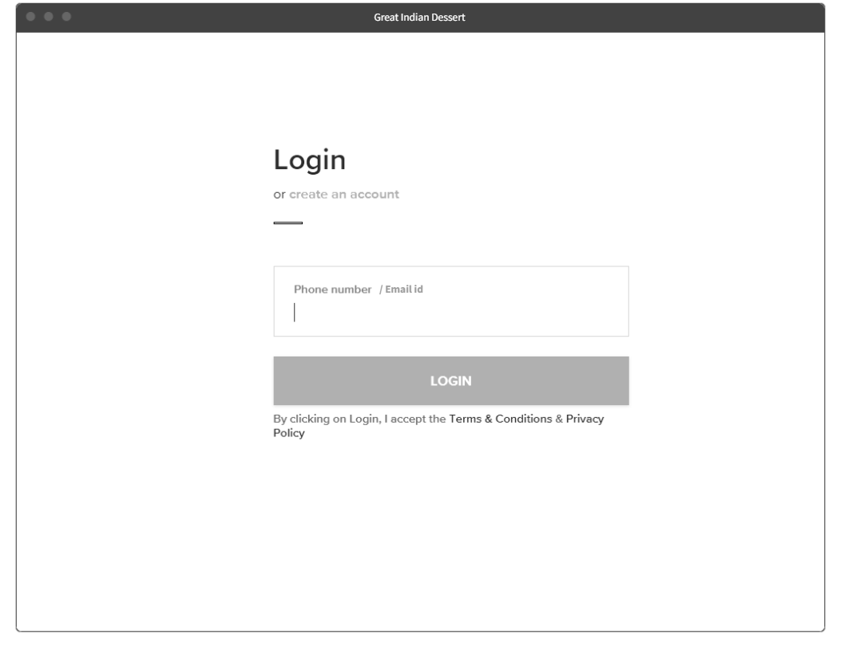

User Home page before Sign in :

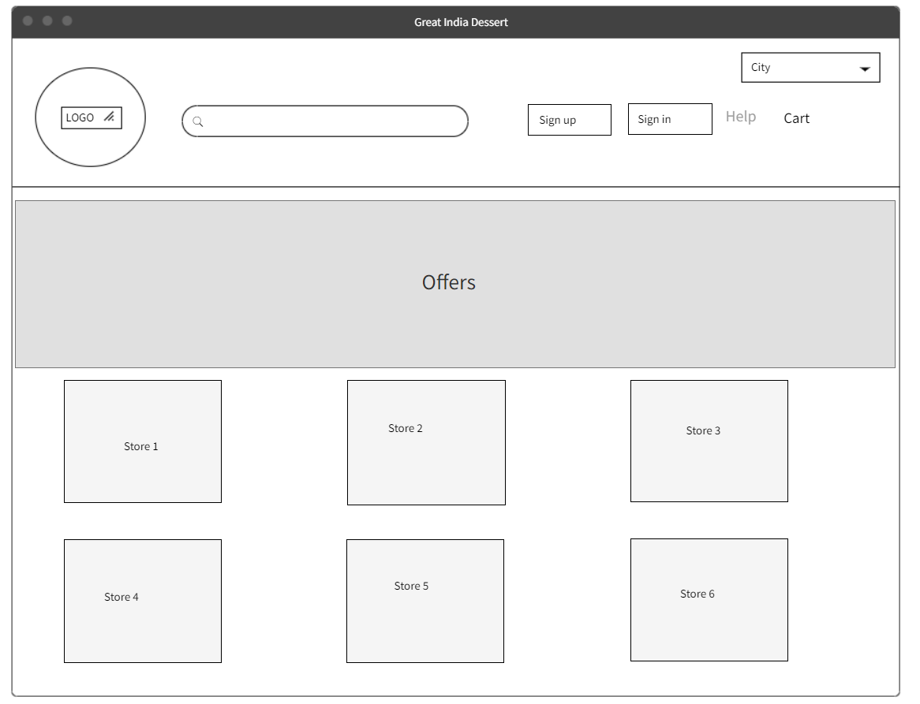

User Home page after Sign in :

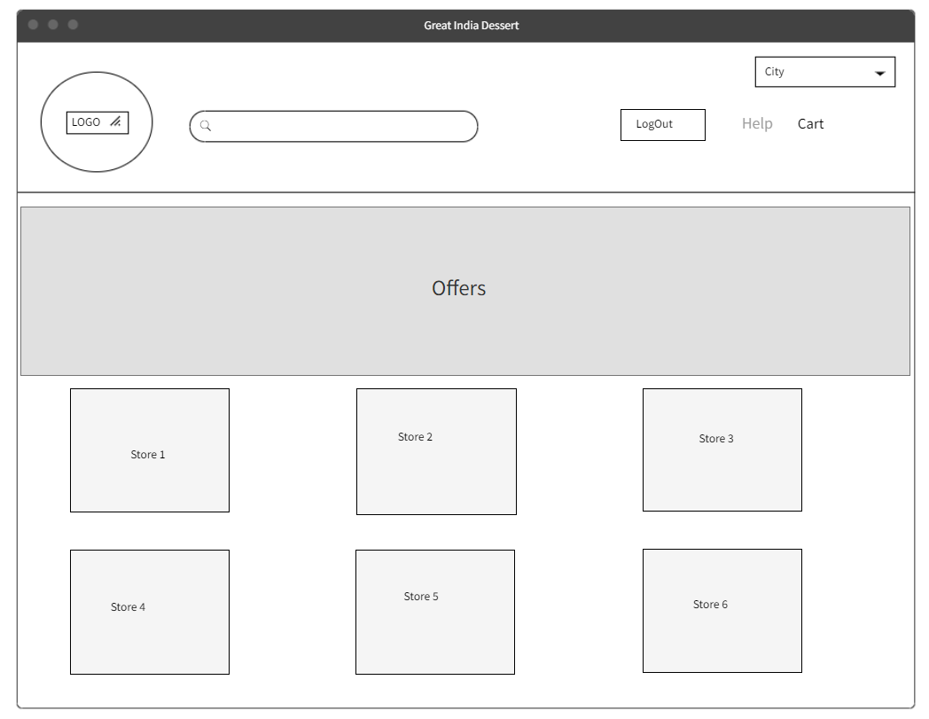

Filters

Customer Menu Page :

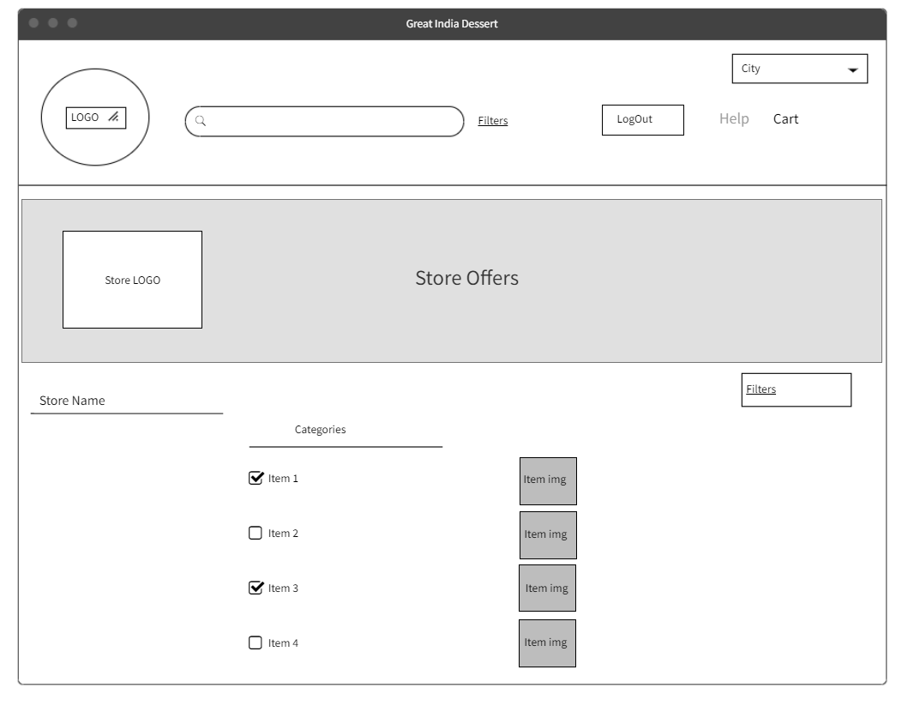

Customer/POC/Delivery agent/ Admin Form page :

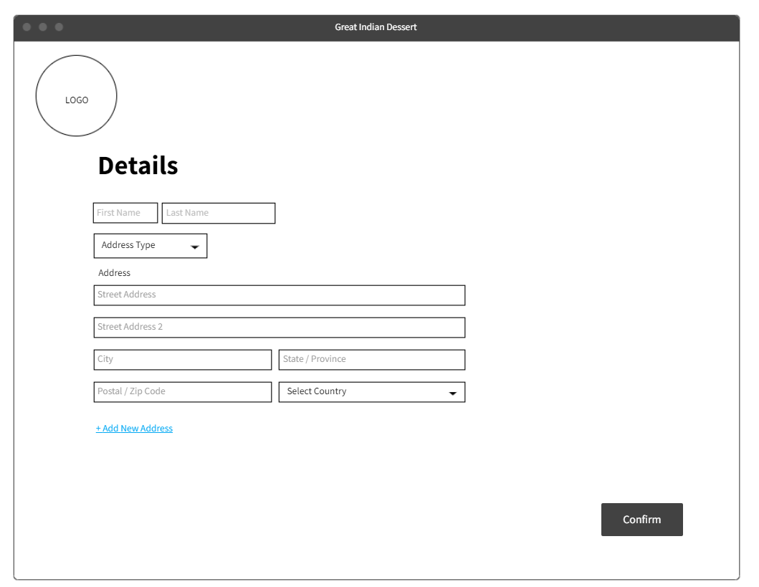

Restaurant/store Form :

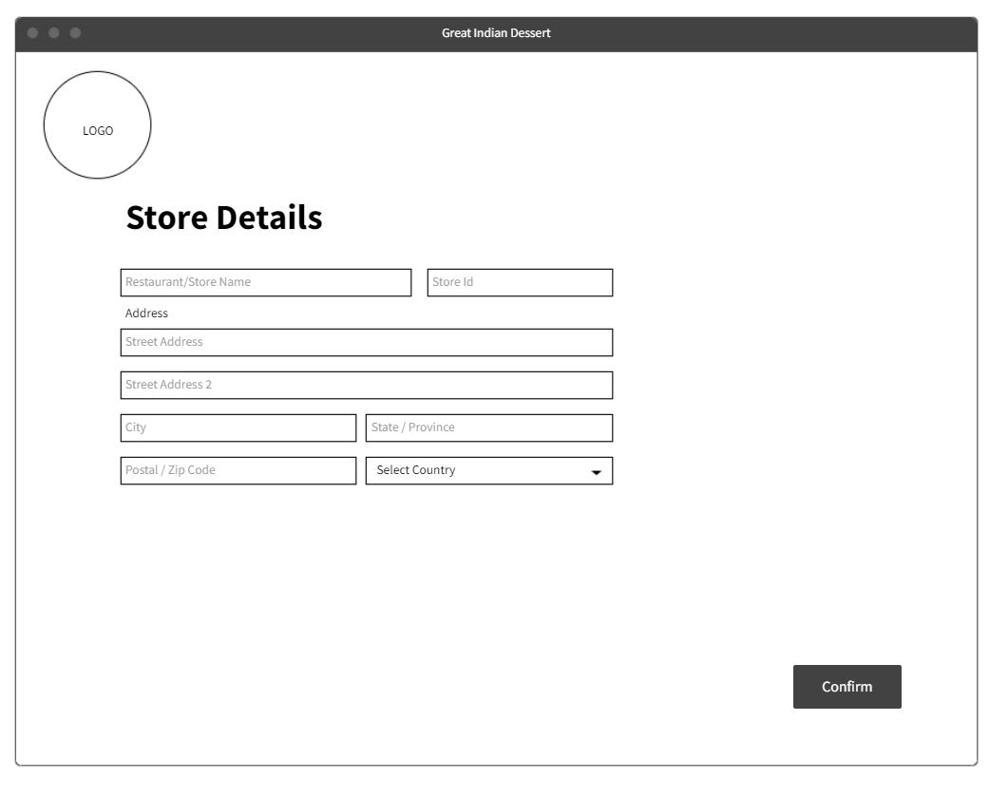

Database Design :

Menu_Table :

|  |  |  |  |
| --- | --- | --- | --- |
| Item_code | item_name | stores | item_img |
| 1 | abc | xyz |  |

Store :

|  |  |
| --- | --- |
| store_name | store_id |
| xyz | 001 |

Delivery_agent :

|  |  |
| --- | --- |
| agent_name | agent_id |
| abc | 001 |

Customer :

|  |  |  |  |  |
| --- | --- | --- | --- | --- |
| customer_Id | customer_name | Email_address | ph_no | address |
| 001 | abc | abc@email.com | 1234567890 | xxxxxx |

Admin :

|  |  |
| --- | --- |
| Admin_id | admin_name |
| 001 | abc |

POC :

|  |  |
| --- | --- |
| poc_id | poc_name |
| 001 | xyz |

Order :

|  |  |  |  |
| --- | --- | --- | --- |
| Order_id | Customer_id | agent_id | store_id |
| 001 | 001 | 001 | 001 |